🧠 Personality Quiz: What Sea Creature Are You?

**Instructions:** Choose the answer that best matches your behaviour or preferences.

Mr Millington’s choices:

**1. How do you usually solve problems?**

A) Quickly, with action and energy

B) Calmly, by observing and thinking

C) By asking for help from others

D) By avoiding them until they go away

**2. What is your ideal environment?**

A) Somewhere loud and exciting

B) Peaceful and quiet

C) Social and lively

D) Constantly changing and unpredictable

**3. How do your friends describe you?**

A) Adventurous and daring

B) Wise and thoughtful

C) Loyal and protective

D) Mysterious and creative

**4. What's your favourite hobby?**

A) Sports or exploring nature

B) Reading or meditating

C) Hanging out with friends

D) Drawing, writing, or creating

**5. If someone is upset, what do you do?**

A) Distract them with something fun

B) Listen patiently and offer advice

C) Cheer them up with a joke

D) Give them space and write them a note later

Results

Results

Based on Mr. Millington’s answers, he is most like an octopus. Octopuses are calm, observant and intelligent creatures known for their problem-solving abilities and quiet nature. They often hide in peaceful places and are considered mysterious due to their ability to camouflage and ability to adapt. Just like Mr. Millington, octopuses are creative - using tools, escaping tight spots, and even expressing themselves through colour changes.

🐙 Common Octopus Fact File

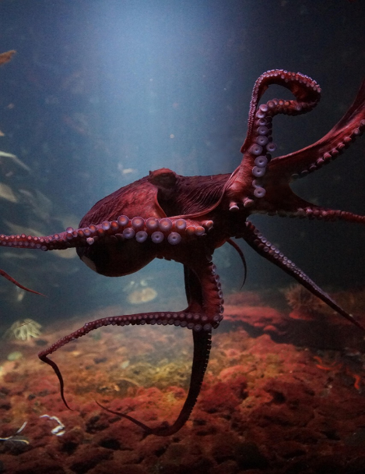**Scientific Name:** Octopus vulgaris

**Habitat:** Coastal waters, rocky reefs, coral reefs, and seagrass beds—found in tropical and temperate oceans around the world.

**Size:** Up to 1 metre (3.3 feet) in length

**Lifespan:** Around 1–2 years

**Diet:** Crabs, shrimp, small fish, and mollusks

**Special Features:**

• Excellent problem-solvers with great memory

• Can change colour and texture to blend in with their surroundings

• Each of its eight arms has suction cups that help them feel and grasp objects

• Releases ink to confuse predators and escape danger

• With no bones, it can squeeze through tiny spaces

**Fun Fact:**

The common octopus has three hearts and blue blood!