When you have watched the clip on the Natural Curriculum website, complete your piece of writing here. Try to remember everything you have learned with your teacher about how to make your writing clear and exciting! It’s fine if you need to go onto a second page.

|  |
| --- |
|  |
|  |
|  |
|  |
|  |
|  |
|  |
|  |
|  |
|  |
|  |
|  |
|  |
|  |
|  |
|  |
|  |
|  |
|  |
|  |
|  |
|  |
|  |
|  |
|  |

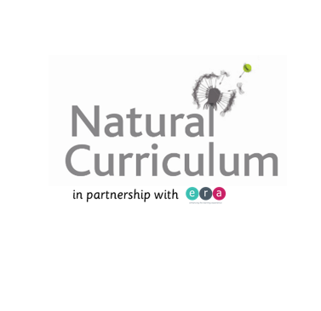**Fill in your details here:**

Name of class: _________________________________

Name of School: _________________________________

**Finally, hand in your writing to your teacher!**